|  | **99acres** |
| --- | --- |

# **Product Dissection for 99acres**

**Company Overview:**

Established in 2005, 99acres is one of the largest real estate web portals that enables the user with a solution to buy, sell or rent the properties in India. It’s an India based company which forms the small scale subsidiary of INFO EDGE INDIA LIMITED; catering various requirements in relation to involvement in real estate ranging from residential to corporate and industrial sectors. The property search engine 99acres which has simple layout and brief property descriptions are today considered to be some of the hit websites among buyers and sellers.

# **Product Dissection and Real-World Problems Solved by 99acres:**

99acres, a leading real estate platform, has addressed significant real-world challenges in the property market through its user-centric and innovative features. The extraordinary service provided by 99acres helps the property seekers, sellers and real estate professional with ease in the rallies of buying, selling or renting a property. Regarding accessibility issue, the problem is solved by the platform, which offers great database of listings which enables users to have choice of numerous facilities regardless of their geographical location.

The platform’s advanced search filters, including location, budget, property type, and amenities, have redefined how users discover properties. These features solve the problem of information search, making it possible for users to refine their search to meet certain requirements and thereby obtain only relevant information. Further, it has provisions such as price, trends, neighborhoods, and loan such as enabling and informative tools that make the otherwise rather shrouded market transparent for the users of 99acres.

Another big step has been 99acres’ ability to offer virtual tours and quality images; the major concern of physically visiting several properties particularly for those in different city/ countries. Since 99acres allows prospective buyers and tenants see properties to be bought or rented from the confines of their rooms, it eliminates geographical and transactional issues that are usually found in property markets.

Additionally, for real estate agents or developers, the creation of an appealing and stylish environment with many opportunities to efficiently present the properties available as well as the opportunity to find buyers and investors is facilitated. By the use of icons, analytic data, and marketing strategies, 99acres helps users to solve the problem of identifying targeted audiences in the competitive market with the help of individual online workplaces.

In conclusion, 99acres has effectively addressed real-world problems by creating a platform that simplifies property transactions, enhances accessibility, and promotes transparency. Its robust features cater to the evolving needs of property seekers and sellers alike, transforming the way real estate is discovered and transacted in today’s digital era.

# **Case Study: Real-World Problems and 99acres’s Solutions**

99acres addresses critical challenges in the Indian real estate market through its innovative features, bridging the gap between property buyers and sellers, and providing a reliable platform for seamless transactions.

## **Problem 1: Lack of Access to Verified Property Listings**

**Real-World Challenge:** Individuals looking for real estate frequently face challenges in locating genuine and verified property listings, resulting in wasted time and concerns about trustworthiness.

**99acres' Solution:**

Offers verified property listings complete with detailed descriptions, images, and information about builders or sellers.Provides filters for budget, location, property type, and amenities to simplify the search experience.Includes trust badges for verified sellers and projects, boosting reliability.

## **Problem 2: Difficulty in Comparing Properties**

**Real-World Challenge:** Buyers and renters often struggle to compare various properties because structured data is not readily available.

**99acres' Solution:**

Tools for side-by-side property comparisons that focus on price, location, amenities, and area.

Interactive maps that display property locations along with insights about the neighborhood.

## **Problem 3: Limited Access to Real Estate in Smaller Towns**

**Real-World Challenge:**

Residents in Tier-2 and Tier-3 cities frequently face challenges in finding a diverse selection of properties.Traditional methods of searching for real estate in these areas can be both time-consuming and inefficient.

**99acres’ Solution:**

By digitizing property listings and making them available across the country, 99acres allows users from smaller towns to browse properties in any location. The platform levels the playing field in real estate by linking rural buyers with urban sellers and agents, thus broadening market opportunities

## **Problem 4: Limited Exposure for Sellers**

**Real-World Challenge:** Property owners and agents find it difficult to connect with a wide audience for their listings.

**99acres' Solution:**

Enables sellers and agents to showcase properties with comprehensive details, images, and videos.Enhances listing visibility through premium advertisements and targeted marketing campaigns.

## **Problem 5: Lack of Market Insights**

**Real-World Challenge:** Buyers and sellers frequently lack access to information regarding market trends and property values.

**99acres' Solution:**

Provides in-depth market analytics, price trends, and locality reviews to support informed decision-making.Offers insights into project completion timelines, legal documentation, and assistance with loans.

# **Top Features of 99acres**

1. **Advanced Search and Filter Options:**  
   Users can refine their search based on location, property type, budget, size, and more, simplifying the process of finding their ideal property.
2. **Virtual Property Tours:**With high-quality images, videos, and 360-degree virtual tours, users can enjoy an immersive experience that saves time and effort for both buyers and sellers.
3. **Locality Insights:**Detailed information about local demographics, nearby amenities, connectivity, and infrastructure development helps users assess properties more effectively.
4. **Property Comparison Tool:**  
   A feature that allows users to compare properties side-by-side based on features, pricing, and locality data, facilitating better decision-making.
5. **Owner and Broker Verification:**Verified listings ensure authenticity, enhancing trust and reducing fraud in transactions.
6. **99acres Advice Section:**Users can access market insights, legal tips, and real estate trends to make well-informed decisions.
7. **Agent Services and Branding:**Tools designed for agents and sellers to increase visibility, manage leads, and monitor performance.

# 

# **Schema Description**

The schema for 99acres captures the core entities and relationships essential for managing property listings, users, and transactions effectively.

**Users Entity**

* **UserId (Primary Key):** Unique identifier for each user.
* **Name:** Full name of the user.
* **Email:** Registered email address.
* **PhoneNumber:** Contact number for notifications.
* **UserType:** Type of user (Buyer/Seller/Agent).
* **RegistrationDate:** When user joined.

**Properties Entity**

* **PropertyId (Primary Key):** Unique identifier for each property.
* **Title:** Title of the property listing.
* **Description:** Description of the property.
* **Price:** Listed price.
* **Location:** Address of the property.
* **PropertyType:** Type (Residential/Commercial/Industrial).
* **OwnerId (Foreign Key referencing Users Entity):** Owner or agent who listed the property.
* **LocalityId (Foreign Key referencing Locality Entity):** Associated locality.
* **Area:** Total area in square feet.
* **Amenities:** List of amenities.
* **Status:** Available/Sold/Rented.

**Amenities Entity:**

* **AmenityId (Primary Key):** Unique identifier for each amenity.
* **Name:** Name of Amenity
* **Status:** Active/Inactive

**Property Amenity Entity:**

* **PropertyAmenityId (Primary Key):** Unique identifier for each property amenity entity.
* **PropertyId (Foreign Key referencing Property Entity):**
* **AmenityId (Foreign Key referencing Amenities Entity):**
* **isAvailable :** true/false (false means currently it is not available in that property)

**Listing Entity:**

* **ListingId (Primary Key):** Unique identifier for each listing.
* **PropertyId (Foreign Key referencing Property Entity):** The property being listed.0
* **UserID (Foreign Key referencing User Entity):** User who created the listing.
* **Description:** Detailed description of the property.
* **Images:** URLs to property images or videos.
* **ListingDate:** Date the property was listed.

**Locality Entity**

* **LocalityId (Primary Key):** Unique identifier for the locality.
* **LocalityName:** Name of the locality.
* **City:** City in which the locality is located.
* **Connectivity:** Description of transportation and infrastructure.

**Transactions Entity**

* **TransactionId (Primary Key):** Unique identifier for each transaction.
* **UserId (Foreign Key):** User involved in the transaction.
* **PropertyId (Foreign Key):** Property involved in the transaction.
* **TransactionDate:** Date of the transaction.
* **TransactionAmount :** Amount of transaction
* **TypeOfTransaction**: Card/UPI/Cash
* **TransactionStatus:** Status (Pending/Completed).

**Reviews Entity**

* **ReviewId (Primary Key):** Unique identifier for each review.
* **UserId (Foreign Key):** User who submitted the review.
* **PropertyId (Foreign Key):** Property being reviewed.
* **Rating:** Numeric rating of property out of 5.
* **Comments:** User’s feedback.

**Enquiry Entity:**

* **EnquiryId (Primary Key):** Unique identifier for each enquiry.
* **UserId (Foreign Key referencing User Entity):** User making the enquiry.
* **PropertyId (Foreign Key referencing Property Entity):** Property in question.
* **Message:** Text of the enquiry message.
* **EnquiryDate:** Date the enquiry was made.
* **ResolvedDate:** When enquiry gets resolved.

**Relationships are:**

* **Users list Properties** – Each user can list multiple properties.but each property is associated with one user.
* **Properties have Listings** – Each property can have multiple active listings overtime.
* **Properties belong to Localities** – Each property is associated with one locality, but a locality can have multiple properties.
* **Properties have Amenities** – A property can have multiple amenities, and each amenity can be associated with multiple properties. The association is managed through a Property Amenities entity.
* **Transactions involve Users and Properties** – A transaction involves one user and one property, and each user/property can be involved in multiple transactions over time.
* **Users enquire about Properties** – Users can send multiple enquiries for different properties.
* **Users review Properties** – Properties can receive multiple reviews from different users.

**ER-Diagram:**

Let's construct an ER diagram that vividly portrays the relationships and attributes of the entities within the 99acres schema. This ER diagram will serve as a visual representation, shedding light on the pivotal components of 99acres's data model. By employing this diagram, you'll gain a clearer grasp of the intricate interactions and connections that define the platform's dynamics.

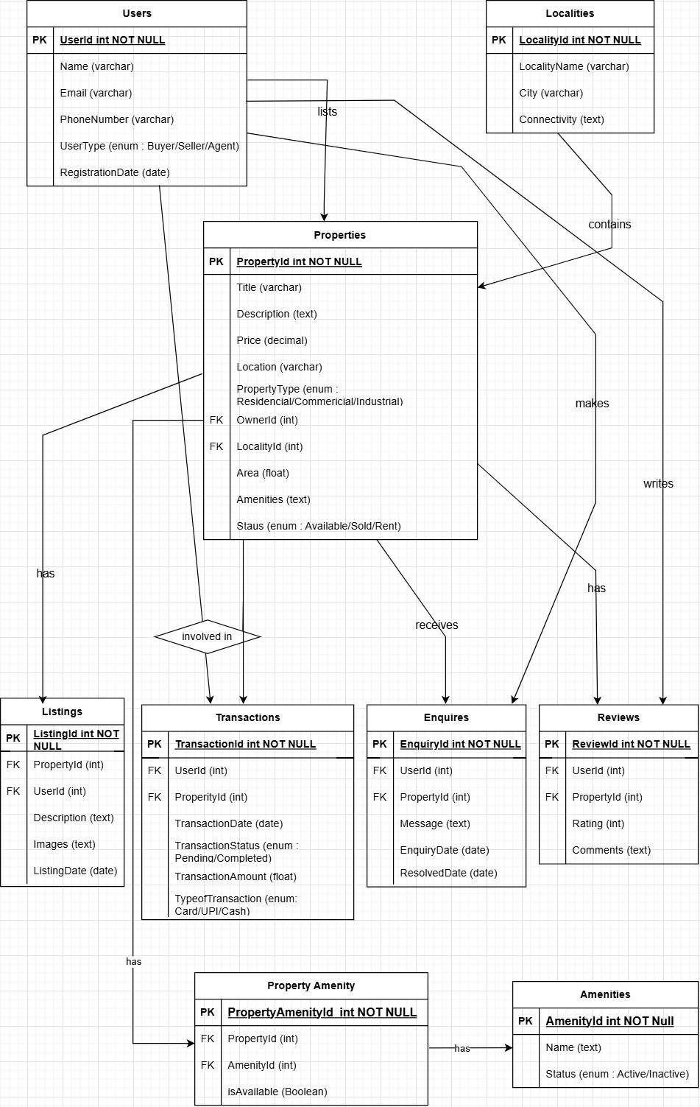

**Conclusion**

99acres utilizes a well-organized schema and cutting-edge features to make property searches and transactions easier. By promoting transparency, accessibility, and user interaction, the platform addresses challenges in the real estate market. Its focus on customer needs not only enhances operations but also establishes 99acres as a frontrunner in the Indian real estate sector, transforming the way individuals buy, sell, and rent properties online.